Below we will define an n-interesting polygon. Your task is to find the area of a polygon for a given n.

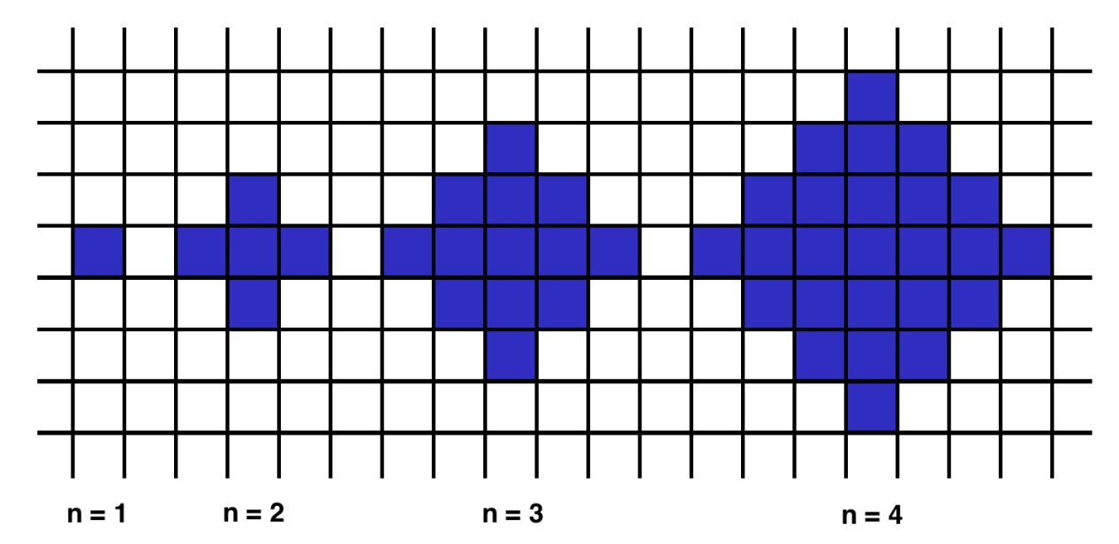A 1-interesting polygon is just a square with a side of length 1. An n-interesting polygon is obtained by taking the n - 1-interesting polygon and appending 1-interesting polygons to its rim, side by side. You can see the 1-, 2-, 3- and 4-interesting polygons in the picture below.

****Example****

* For n = 2, the output should be  
  shapeArea(n) = 5;
* For n = 3, the output should be  
  shapeArea(n) = 13.

Notes:

* Tilt your head!
* The optimal solution has just 1 line of code!